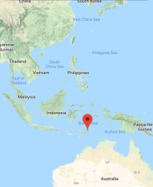
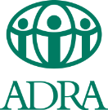
Viqueque Improved Water Access Proposal
Implemented by ADRA Timor-Leste

Background
When ADRA meets with rural communities in Timor-Leste to discuss their needs, consistently people say that access to clean water is their highest priority. Approximately 40% of rural Timorese do not have a safe water source within 30 minutes’ walk from their homes. The responsibility for collecting water often falls to women and children. Water is typically collected from streams and rivers and the time spent collecting water often results in children missing school. Timor-Leste has very high rates (50.2% in 2016) of children under-5 malnutrition and stunting and one of the key factors contributing to this problem is sickness caused by the lack of clean water and sanitation facilities.
Statistics of percentage of households with water and sanitation access in Timor-Leste (source: https://washdata.org/data#!/tls)

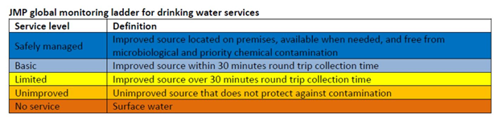

Water Provision
ADRA Timor-Leste has extensive experience and capacity to providing rural communities with access to safe water and raise awareness to hand washing and sanitation. Since 2010 ADRA has been working in Viqueque, a remote district in South-east Timor-Leste, and has constructed two large-scale water systems providing water to entire villages, and has constructed more than 20 small-scale bore wells at schools, medical clinics, community vegetable gardens, and community water access points in various villages throughout the district. In call community water development projects ADRA works with the local government authorities in the Ministry of Public Works to plan the placement of wells and to train a committee of community members in maintenance and collection of small user fees to cover the costs of operations and maintenance. Through its water projects, ADRA has helped thousands of people by providing access to water close to their homes.
Villages Lacking Water
Identified by Viqueque Municipal Department of Public Works Water Division (SAS) (Nov 2018)
Post Administrative | Suco (village cluster) | Aldeia (villages) | Households | Population
Viqueque | Uma Uain Craic | Naeboruk | 87 | 400
 |  | Bosabein | 143 | 725
 |  | Cailoi | 72 | 247
 |  | Loho | 27 | 148
 |  | Uhacae | 33 | 270
 |  | Halderai | 57 | 295
 | Bahalarauain | All aldeias | 911 | 4210
 |  | Total | 1330 | 6295

The above data is from the Municipal department of public works shows the population in two village clusters that lack access to water. The project team is currently (Nov – Dec 2019) doing the water survey in three additional sucos: Uma Uain Leten, Matahoi and Babulo. The result from the survey will be included in the detailed proposal.
Uma Uain Craic and Bahalaruain are located at lower elevations at the base of the mountains. The water table in these areas is not very deep and can be reached through a bore hole between 15-40 meters deep.
A water system in a community provides clean water for approximately 100 people. The water is used not only for household uses of cooking, cleaning, and washing, but the water often allows people to grow vegetables near their houses or create small fish ponds. Having a source of clean water nearby has tremendous positive effects on health, nutrition, and time savings allowing children to spend more time on their studies and women to engage in other activities that are beneficial to their livelihoods and wellbeing. Several health posts in these areas also do not have a source of water.
Map of Viqueque Municipality
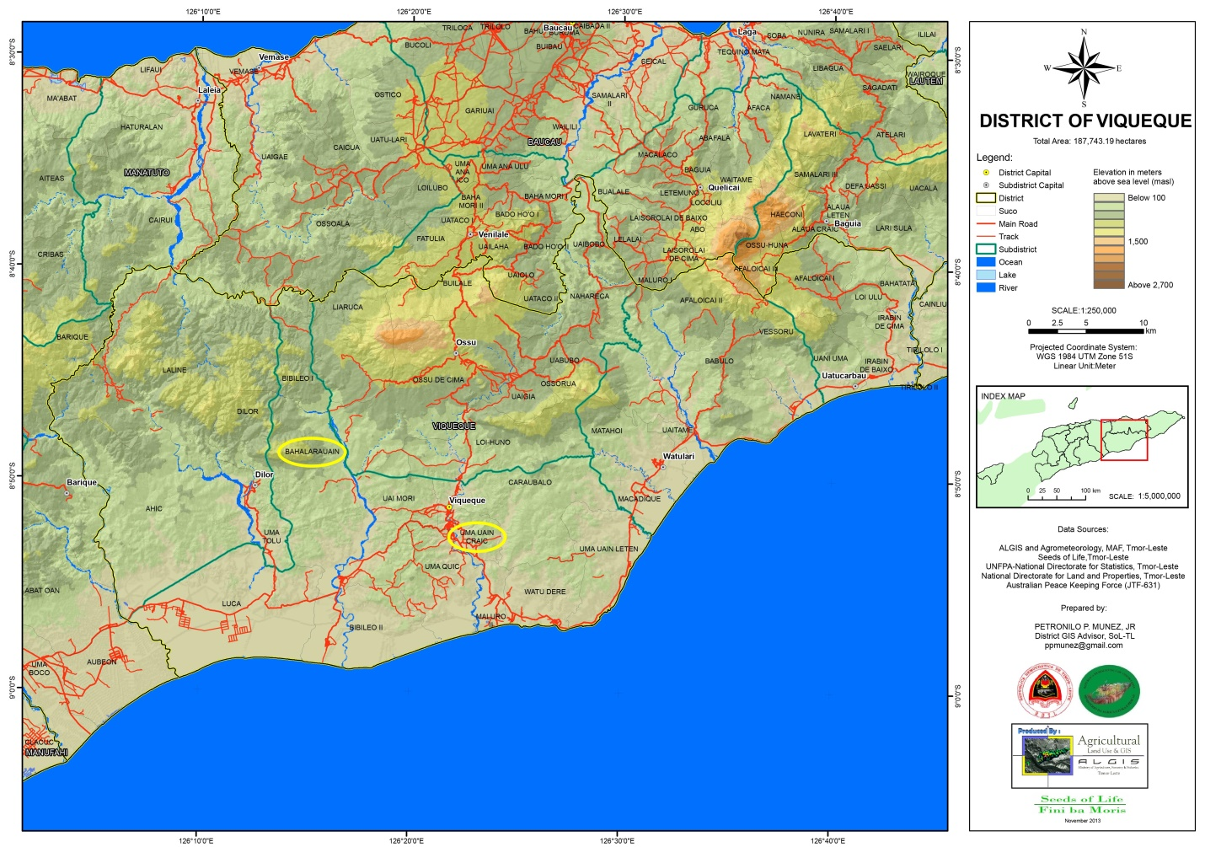

Water Systems
ADRA’s technical water team works with the local community and Municipal Department of Public Works Water Division (SAS) to plan the location for the bore wells and tap stations based on the landscape and meeting the needs of the communities. The community is also expected to contribute some volunteer labour for the construction of the water system.
For the bore well systems, ADRA’s water team uses a series of galvanized steel pipes fitted with a large drill bit and uses a series of tools, pulleys, and levers manually turn the drill as it reaches down into the ground. At the same time, water is pumped down the drilled hole to flush out the displaced soil. Water is usually reached after drilling down between 15 and 40 meters. This can be achieved within a few days of drilling. The bore well is then sealed with a protective PVC casing and an electrical pump is connected at the surface. Water is then pumped to a poly-plastic 3200L elevated tank and connected with plumbing pipes to one or more tap stations. The majority of rural Timor-Leste has access to free electricity and the pump has an automatic shut-off function when the tank is filled to capacity.
Costs
Based on the data from previous water system projects, the average cost of a bore well water system is approximately:
$4000 USD. This covers costs of the drilling equipment, materials (steel pipe, casing, electric pump, tank, pipes and plumbing materials, taps, etc.), and costs for transportation, and staff salaries.
$4000 ÷ 100* beneficiaries = $40* can provide clean water for one person
* on average
Photos
1, 2 – Traditional ways of collecting and transporting water
3, 4 – Drilling bore holes
5 – Tap station
6 – seedlings at a kitchen garden created with water from ADRA water system
7 – ADRA’s water technician teaching a teacher how to work water pump for a school
water system
8 – Water tank and tap station at a school
9 – Bore well water system at community vegetable garden and fish pond
10 – Children using water at ADRA water access point

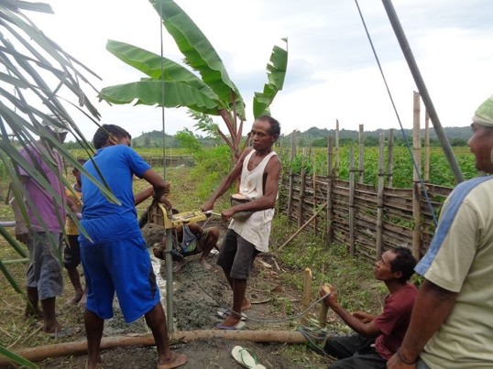
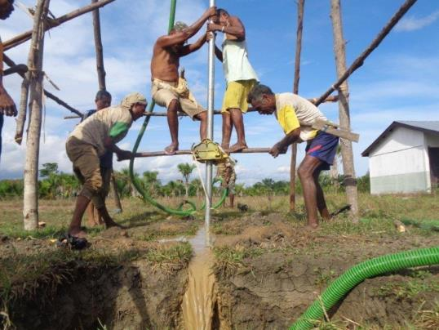
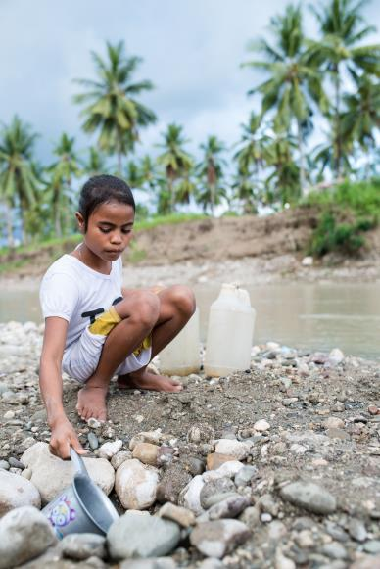
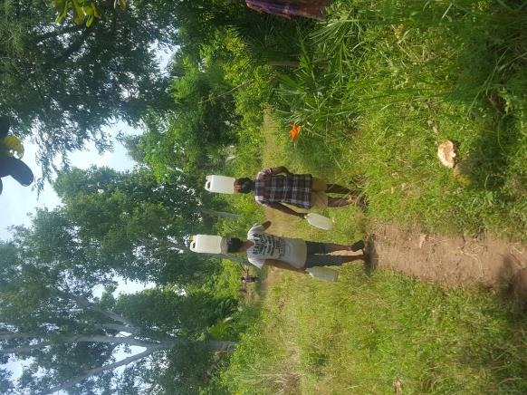
1
2
4
3

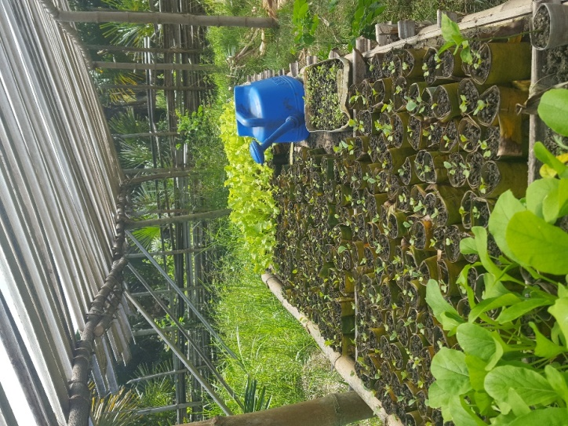
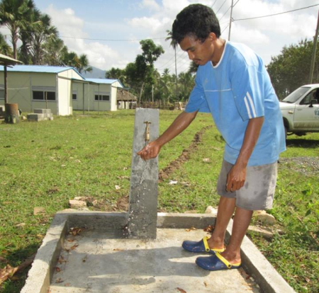

6
5

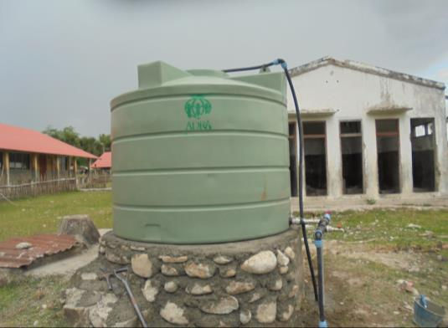
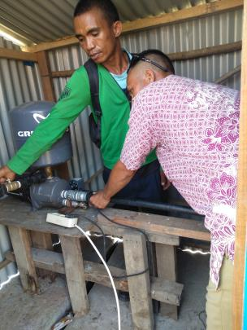

7
8
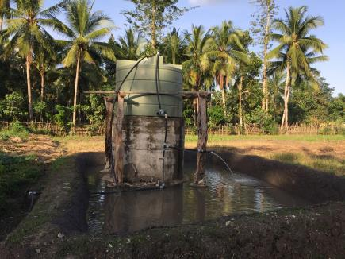
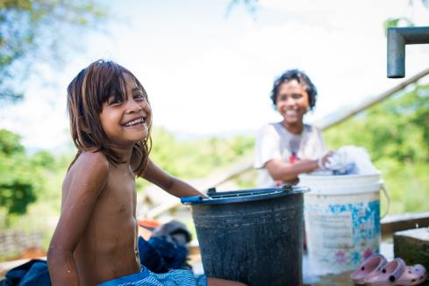
10

9

